Panther Creek High School World Languages Pedagogy

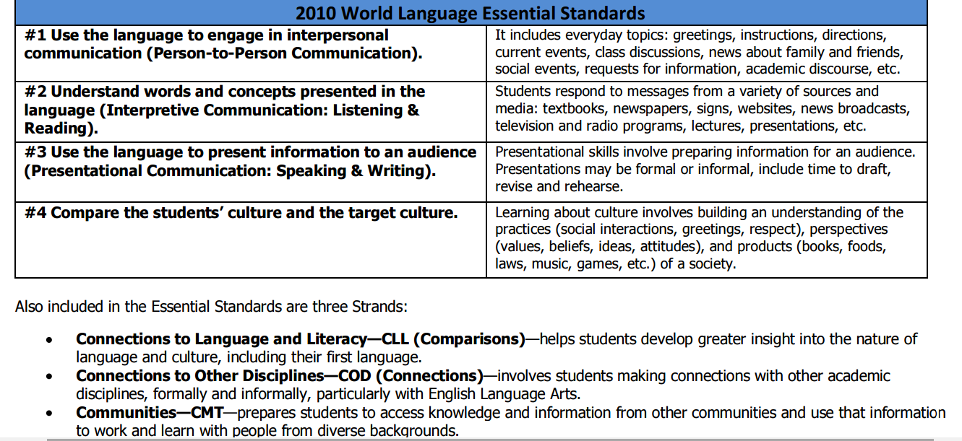
- According to the essential standards the students will be assessed on their interpersonal and presentational skills (in speaking and writing), their listening and reading comprehension and their understanding of their culture and the culture of the Spanish speaking world. Grammar and vocabulary are incorporated into these skills – not the other way around.
- The goal should be increasing fluency and using the language, not passing tests.

